Window Shopper –Completing the Purchase

Window Shopper does not offer an option to create a requisition but will provide the details you need to create a Purchase Order.

Step | Do This:
1 | Once you have added an item to the Shopping Cart, you will have access to detailed information you can add to your Purchase order:  - The more info...link next to the Supplier’s name will display detailed information at both the Supplier and Contract levels.  - The supplier’s website link will take you directly to the supplier’s website where you can obtain additional information about the item.  - The more info...link next to the SWC Contract number reveals an abbreviated version of contract information.  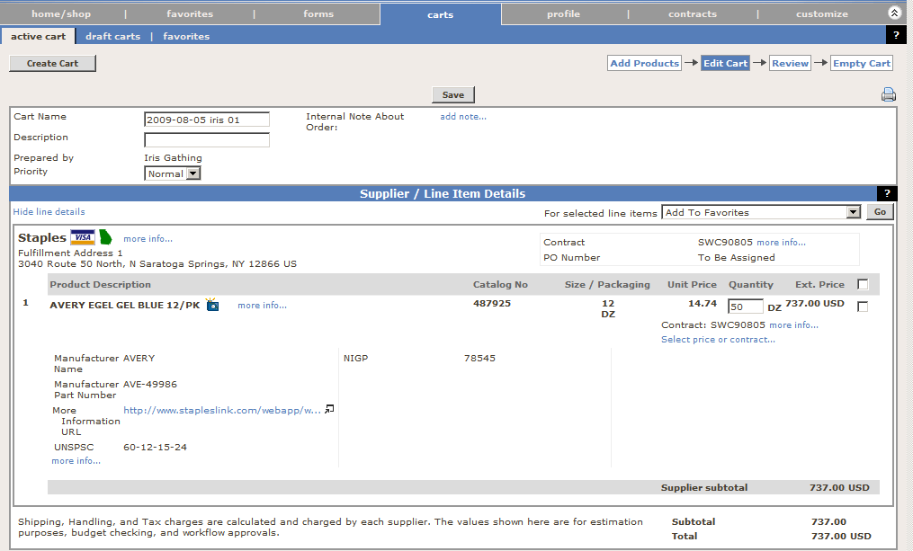
2 | Copy the item description and the Statewide Contract (SWC) number from the Shopping Cart and Paste this information into the Description and Contract ID fields on your Purchase Order.  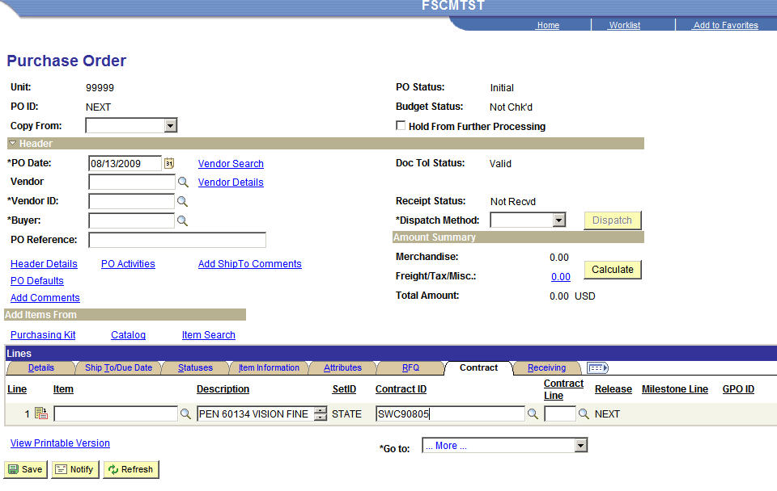
3 | Another bit of information you should capture for the Shopping Cart is the Manufacturer's ID or SKU number.  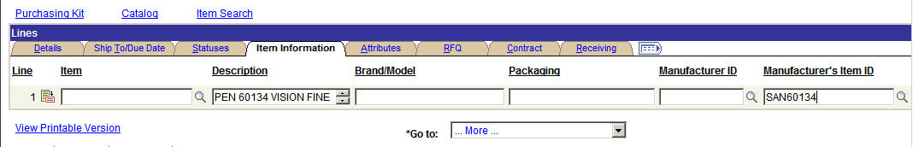
4 | End of Procedure

